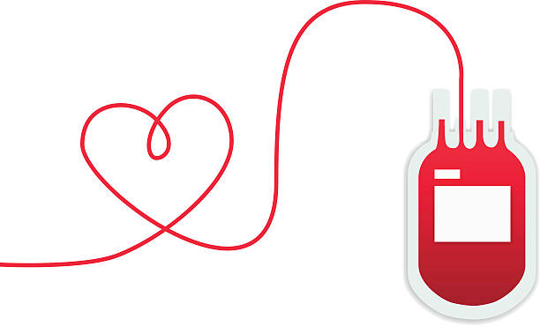
Mobile Blood Drive Report

Organization: VFW Post 1461- Belvidere
LIVES SAVED:
33
Date: Thursday, July 23rd, 2019
Time: 2:00PM-6:00PM
Next Drive Date Scheduled: November 12th, 12:00-4:00 PM

Blood Drive Goal: 30
Total Units Collected: 11
Donors Scheduled: 9

Donors Appeared: 16
Deferrals: 5
New Donors: 4
------ Thank you to all those who participated in this year’s blood drive! -------

PAMELA DIBENEDETTO
SHEILA GONZALES
SUSAN SHOTT
ALISIA MEDRANO
ROBERT BLAND
DALE SPARKS
JOHN DARLEY
SANDRA PAULSON
JOSEPH TODD
THOMAS OSHEA
KEITH BODEY
MICHAEL ISHAM
STEVEN BERNAL
REBECCA COULSON
WANDA CALDWELL
BRANDEN AVILA

